##### BAG WITH TOP HANDLE

A bag with a top handle typically refers to a handbag or purse that features a single handle positioned at the top of the bag. This type of handle allows for easy carrying by hand or in the crook of the arm, giving the bag a chic and sophisticated look.

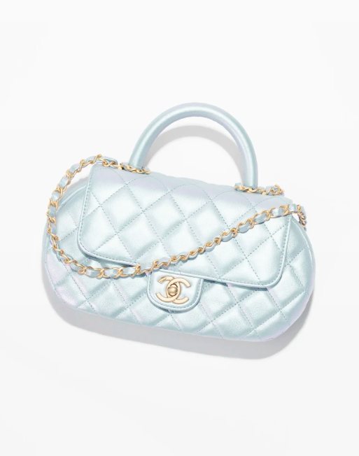Here are some common characteristics and considerations for a bag with a top handle:

1. **Design**: Bags with top handles come in various shapes and styles, including tote bags, satchels, doctor bags, and structured handbags. The design can range from sleek and minimalist to more ornate and detailed, depending on your preference.
2. **Functionality**: A bag with a top handle is versatile and suitable for different occasions, from professional settings to casual outings. It offers convenience for quick access to your belongings and can complement a wide range of outfits.
3. **Size**: Top-handle bags are available in different sizes, ranging from small and compact styles to larger options that can accommodate more items. Consider your daily essentials and how much storage space you need when selecting the size of the bag.
4. **Material**: These bags are crafted from various materials, including leather, faux leather, canvas, nylon, and more. The material choice can influence the overall durability, appearance, and maintenance requirements of the bag.
5. **Closure**: Top-handle bags may feature different closure types, such as zippers, magnetic snaps, clasps, or flap closures. Choose a closure that provides security for your belongings while also being easy to open and close.
6. **Interior Organization**: Look for a bag with interior pockets and compartments to help keep your belongings organized and easily accessible. This can include pockets for your phone, keys, wallet, and other essentials.